Essential of Pictograms for Effective Hospital Signage
Chai Sunyavivat, Supawadee Boonyachut
King Mongkut’s University of Technology Thonburi, Thailand
The European Conference on Arts & Humanities 2013
Official Conference Proceedings 2013
Abstract
Language serves as a tool of social interaction and communication among people.Communication between building and building user needs signage as a device. Fromthis research, texts associated with pictograms help the building to communicate to its users more effectively. Pictogram reduces about half of the perception time used to perceive sign with text only across all literacy levels, especially for people who could neither read nor understand Thai or English. The pictogram designed in this study mainly deals with elderly, and group with vision problems have found that it should possess a large portion of white background as both sample groups have identified that it is the clearest and easiest mode for visibility. At pictogram wrap up tested, medical profession detected mismatched iconic information. This finding proved the following: first, pictogram might not be interpreted correctly by all groups of users since patients cannot detect mismatched iconic information; second, cognitive effect of iconic information must relate to its function and familiarity to users. Thus, designer should be familiar with all iconic information prior to design in order to rid mistakes and to design good quality and effective image-related graphic symbol for competent communication which makes pictogram essential for signage. Keywords: Pictogram, iconic information, perception time, sign
Introduction
To communicate well with building users, the elements such as directional sign, floor sign, and directory help the users to determine locations and to go around the building accessibly. All kinds of signs are also very important in case of fire. In public buildings like hospitals which have large quantities of users, signs are more important in solving communication problems. In Thailand, signage in hospitals is mostly based on a lettering which is not a universal language. Patients who could not read both Thai and English cannot perceive information on signs. Graphics, symbols, and pictograms can ease reading as well as optimal contrast of colors since they are universal. However, there are other factors for signage design: font and letter size. In addition, patients with vision problems such as nearsightedness, farsightedness and especially color blindness are also considered in this research. The color blind people are identified by genes or eye sickness which is mostly red-color blindness. Color blind people cannot distinguish the colors especially red, green, yellow, and blue. However, these kinds of people can differentiate blue more than other colors1. Charuta (2004) concluded that the elderly can clearly read dark blue information on white
background.
Likewise, Norman (1990) concluded that a pictogram is better than a label, and recognizing an image is easier than reading text. Many researches also reported that pictograms have the potential to be interpreted more accurately and more quickly than texts. They are more noticeable, and more easily understood at a distance compared to textual information. However, inappropriate design pictograms with complex contents can cause problem for people with low literacy while basic pictograms can cause problem for literate people.
Objective
The research aims to study the perception of elements involved in sign design for the hospital, focusing on the essential of pictogram in sign.
Methods
The following methods are used:
1. Literature review.
2. Interview the key informant of Ban Phaeo Hospital. Several obtained information is general data, statistics of inpatients and outpatients, statistics of personnel, and existing signage.
3. Determine condition and perception time of existing sign in Ban Phaeo Hospital.
• Interview 121 outpatients and 13 hospital personnel to identify the condition of existing signs and uses as development guideline.
• Test the perception time of existing sign by 100 sample population with the same demographic as patients.
4. Find appropriate design elements for new sign by 100 sample population with the same demographic as patients.
• Test each element: color, font, pictogram separately.
• Test new sign which combines all elements.
• Compare perception time of existing sign and new sign.
• Analysis.
5. Redesign pictogram according to sample group’s comments and suggestions.
6. Informal discussion with hospital personnel.
7. Redesign and seek final conclusion from hospital personnel.
8. Final touch on all pictograms.
Condition and perception time of existing sign in Ban Phaeo Hospital The research case study was selected from autonomous health facilities. Therefore, Ban Phaeo Hospital (Public Organization), the first autonomous health facility in Thailand, was chosen as it is on the growing stage. To date, it has head quarter in Samutsakorn, 4 more branches to serve Samutsakorn province, 2 branches in Bangkok, and 1 branch in Nonthaburi. The development of head quarter and all branches will be prototyped to other autonomous health facilities in the future. Ban Phaeo Hospital is a medium sized hospital with 180 beds, 14 health departments and 8 service sections. The existing signs in the case study of Ban Phaeo Hospital, and most hospitals in Thailand were mixed patterns: text only, pictogram with text, and number. They caused hospital patients to be confused during their diagnostic process. In particular, the elderly having vision problems and low literacy could not read the signs to determine the exact direction or accurate diagnostic procedure. Eye OPD in Ban Phaeo Hospital tried to improve their signage, but until now they cannot solve the problem. The early step of research dealt with interviewing patients and hospital personnel to identify the condition of existing signs and uses as development guideline. There were 121 patients from Medical OPD, E.N.T. OPD, and SurgicalOrthopedics OPD being interviewed. A little over half of the patients, 53.85%, indicated that they were confused by the existing sign. In case the hospital signage would be changed, 57.02% of the patients preferred the text only as the existing sign and a quarter of sample population recommended adding pictogram along side with text. Another interview was conducted with hospital personnel only involved in public relations, porter jobs, and medical equipment delivery. A little over half of the personnel, 53.85%, preferred the text only as the existing sign in Figure 1.
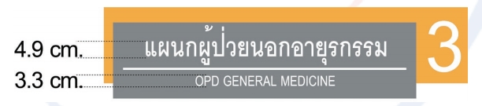
Figure 1. Existing sign in Ban Phaeo Hospital
Over half of the interviewed patients preferred the sign with text only because they are old patients who are accustomed to the medical checkup routine. But the test results for white DB Fongnamas Bold font on gray background showed that only 75.75% could see the letters clearly, 15.67% for the letters being too small, and 2.61% for letters being too close. The existing color tone was 83.47% clear and too light color was 16.53%. After the interview, test of perception time on existing sign was made. The result from the test showed that as the age of a patient increases, the perception time also increases; see Figure 2.
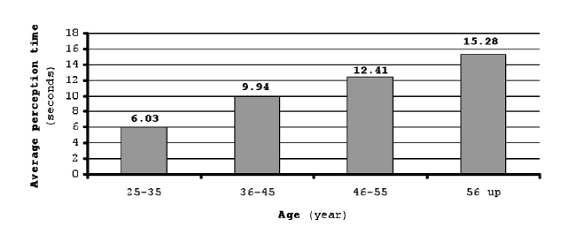
Figure 2. Relationship between age of the patients and perception time
The test also found that the sample group with education level below diploma spent highest average perception time at 12.45 seconds; see Table 1. However, almost a quarter of sample population could not read and their perception time was infinite. This group could simulate patients who could not understand both Thai and English. Table 1. Relationship of education level and average perception time of existing signs with text only
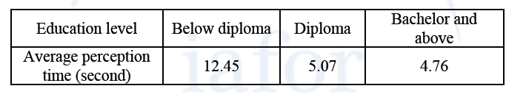
The perception time to understand information in the existing sign is inversed with education level. However, for some difficult interpretation either Thai or English medical terms likewise these seven departments: Obstetrics and Gynecology OPD, Eye OPD, Medical OPD, E.N.T. OPD, Pediatrics OPD, Surgical - Orthopedics OPD, and Admission Centre are poorly understood by all patients across all ages and education.
Pictogram as universal language
The use of pictures or images to convey messages was as long as the prehistoric period which appeared paintings on the cave wall. Pictures were used in telling stories, and communication; they reflected the people’s will in the note for future generations although they did not have any written language. As time lapsed and as human community grew and developed, pictures or images were acquired in abstract form or symbol. Pictures were used to provide information to people in the form of signs in 1389 by King Richard III. The King commenced that ale brewery in the United Kingdom must provide the same symbol in front of their properties, so the inspection of ale could be done conveniently throughout the country. Another important reason is that most people in the Middle Ages could not read. Therefore, a picture or a symbol sign was the right choice to communicate and identify various services and shops effectively since it was a universal language.
To this day, countries with low literacy rates like India and Egypt still use symbols for almost everything. For ease of voting, India has used various symbols to represent the election party on the ballot. In Egypt, symbols have been used to define the election candidates in the ballot. In Thailand, signage in hospitals is mostly based on a text which is not a universal language. Patients who could not read both Thai and English cannot perceive information on signs. A pictogram is a pictorial resemblance to a physical object to convey its meaning and can therefore ease reading.
For patients group that could not read or understand both Thai and English, pictograms in all hospital signage can convey messages better than the texts that cannot represent any meaning. On the other hand, medical terms that are difficult to interpret also merely represent meaning. In all cases, pictograms can better be stored in memory in both visual and symbolic forms (Paivio, 1986). At a far distance and glancing gesture, pictograms can identify meaning at a quicker speed compared to texts. However, pictogram is also disadvantageous because it might not be interpreted correctly by all groups of users across all cultures. It also takes many years for any pictogram to reach a maximum effectiveness. The effectiveness of pictograms relies on their characteristics such as color, shape, and visual complexity; however, the main difficulty in processing the iconic information represented in pictograms is related to the meaning accurately conveyed.
Design elements in new sign
The design elements in making sign easy to avoid any misunderstanding the diagnostic procedure are the salient points of this research. Thus, all elements: color, lettering, and pictogram for the new sign, were separately tested before combining them in the new sign for testing perception time. Many color tones were tested for ease of reading as a relevant quality. Finally, the white lettering against a colored background, light blue, was selected as it always looks finest and clear if there is a sufficient contrast3 and it is also Ban Phaeo Hospital’s corporate identity. White letter on light blue background is theoretically visible since the contrast of saturation occurs when “two colors with different intensities such as electric blue and neutral blue gray are used together”4. The new signs used Freesia DSE font at the height of 5 cm. for Thai letter and 2.8 cm. for English letter. Information was written in white with blue background as the corporate identity of the case study. The new signs were tested at 2.40 m. high above floor with visibility distance of 6 m. The responses to both font and color were clearly visible at 95% and 96% respectively.
Comparison of clear visibility between existing sign and new sign as shown in Figures 3 and 4 shows that the attraction by bright color - orange - cannot help the patients to direct themselves to the destination. As a result, the main information in white letter on grey background is a great neutral color. Because of the contrast of saturation5, it is very difficult to be visibly seen by elderly people, the majority group of users in hospitals.
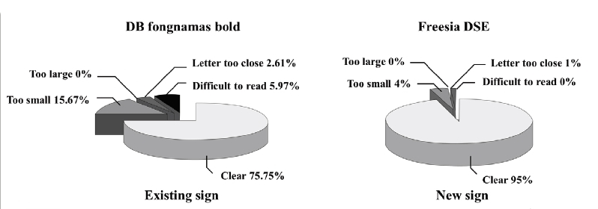
Figure 3. Comparison of the test results of font and letter size
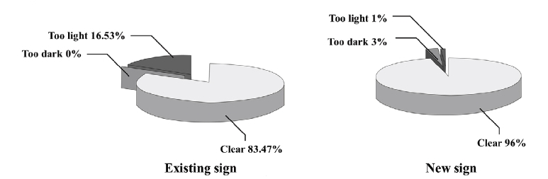
Figure 4. Comparison of the test result of color
Pictograms decrease conveying time of messages
Prior to capturing the perception time of pictograms, the pictograms were designed and tested extensively. They were designed based on image-related graphic symbol concept with blue image against large proportion of white circle background. This was made in order to frame and differentiate pictogram from text message. This design criterion was pinpointed by the farsighted and color blinded sample population. They asserted that it was the clearest visible pictogram design. Additionally, they explained that a large portion of white would make it easy to perceive.
Pictogram design starts with the first step of identifying the information and the recipients. It is followed by drawing of the image which might be very simple or complex, depending on the information. Designers should be aware that there are many ways to represent information. Thus, it is necessary to use the most understandable image during the drawing stage. The image should be reduced to have only its essential parts either by using stick figures or profile, or by removing any features, details or characteristics that are not essential to represent things or ideas. This can lessen the tendency of confusing the viewer with only the real significant meaning. Finally, testing the pictogram on sample group should be done to determine its effectiveness in transmitting the intended meaning.
The first round of testing pictogram was done with a hundred sample population. Three different pictograms were tested for design quality to determine whether the icon matched the service department it represented. The popular choice of each department was redesigned or modified to ensure a correct understandable image.
Future retest involves a combination of pictogram and prior selected font. The retest of pictograms focuses on the sample population with equivalent demographic quality as the first round to ensure the precision of results. The percentage of correct identification varies from 80-100% according to the pictogram used. According to ISO standard, ISO 9186-1989, a pictogram is accepted if 67% of the users understand it in an unquestionable way or almost unquestionable. While in the United States, the pictogram is accepted if it is understood by 85% of the users, ANSIZ 535-19876. In contrast, the retest of pictogram in this research uses an acceptance level of 95% since the research is conducted in a small number of sample populations, referring to the same hundred sample group. Therefore, many pictograms were redesigned and retested until they had reached 95% acceptance level. These pictograms included four extra departments: E.N.T. OPD, Radiology, Laboratory, and Surgical - Orthopedics OPD, which had difficulty to link image with information as commented by the sample population. However, four departments, Surgical - Orthopedics OPD, Admission Centre, Dental OPD, and Spa, have the perception time for signs with pictogram higher than that of the sign with text only, Figure 5.
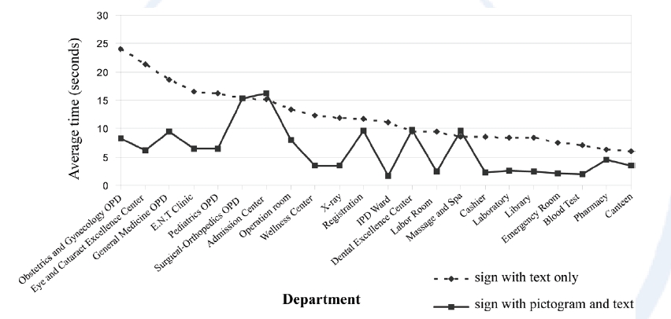
Figure 5. Comparison of perception time for signs with pictogram and sign with text only
Comments from the interview session after the test reveal that four departments with higher perception time are slightly difficult to understand either because the pictogram does not stand out from the background from too light line weight or the sample population is not familiar with those departments. Only Surgical - Orthopedics OPD pictogram obtains comment on its iconic information. Generally, the entire signs with pictogram can decrease the average perception time about half of the time used for the sign with text only; see Figure 5. However, the average perception time of sample population with low literacy is higher than the high literacy group’s as same as the average perception time of sign with text only

